Dear Jacqueline,

Thank you for agreeing to run a session for us at Bexley Grammar school on **Wednesday 24th November**. Please ensure all presentations and worksheets needed on the day have been sent through to me by **Monday 15th November** so that they can be made available for you on the day.

Please find details of the day below

| Year Group Assigned to | Year 9 |
| --- | --- |
| Number of students per session | 24 in one group |
| Time to arrive on site | 8.00 |
| Estimated end time | 3.05 |
| Topic | Computer Science Workshop |

**Timetable for the day:** you will be based in the G1. This room is half a classroom and half a computer suite.

| Session 1  8.35-10.35 | | break  10.35-10.55 | Session 2  10.55-12.35 | | Lunch  12.35-1.25 | Session 3  1.25-3.05 | |
| --- | --- | --- | --- | --- | --- | --- | --- |
| G1 | | M3 | G1 | | M3/Canteen | G1 | |

**Directions and Parking**

There is on site parking at the furthest gate away from Danson Park in the visitors car park

There is additional parking in the nearby roads.

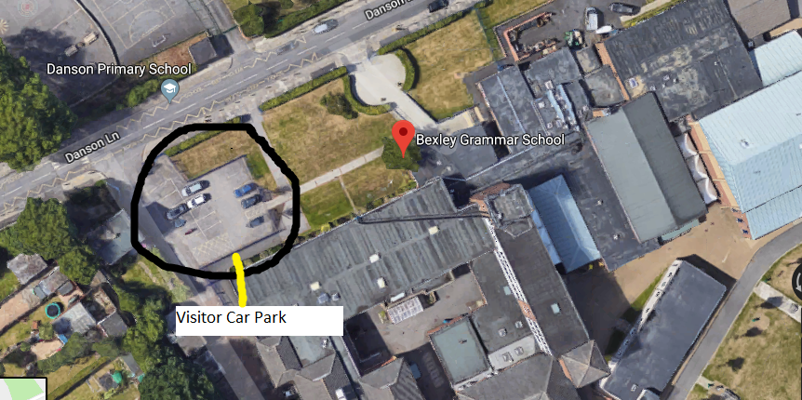

If travelling by train, the nearest station is Welling Station

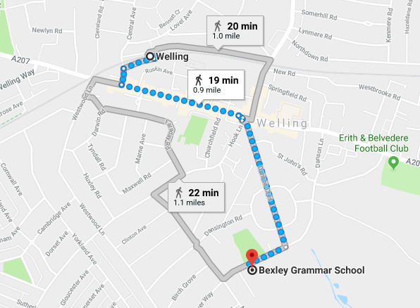

**Lunch**

Unfortunately, due to budget cuts we can no longer provide lunches for visitors. Tea, Coffee and snacks will be available in the morning and at break time.

Should you wish to heat food, we have facilities in the staff room to do this, alternatively you can pay by cash in the canteen however.

Alternatively Welling and Blackfen high street are a short driving distance away with a number of food options.

**Arrival**

Please arrive at 8.00 to the main school reception. I will collect you from there and show you to your rooms for the day.

**ICT Facilities**

Each room has a projector and computer with internet access.

Thank you in advance

Ruth Lusted